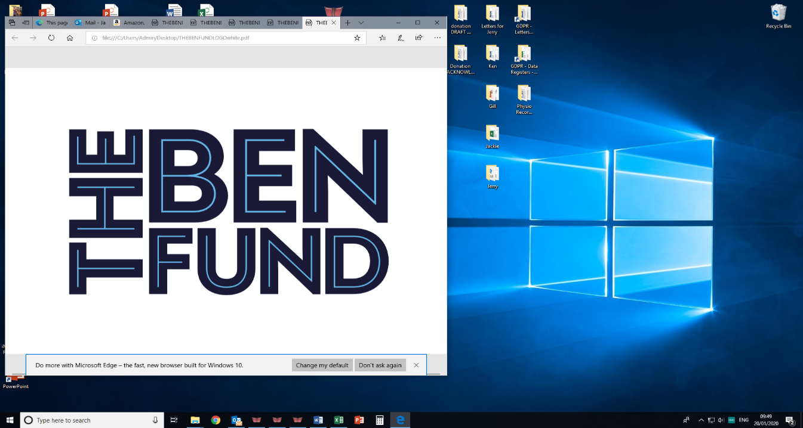

Fitness Instructor
Post Title: | Fitness Instructor
Salary: | £15.36 per hour
Location: | St Michaels Lodge, Langho BB6 8BG
Responsible to: | Physiotherapist/Clinical Services Manager
Job Purpose: | To provide exercise classes to the Charity’s members.
Key responsibilities:  (This is not an exhaustive list, but illustrative of the general nature of the work to be undertaken) | To deliver a range of effective and efficient classes, using the correct and appropriate equipment. Classes include Pilates, Yoga, Spin and Aqua Aerobics.  Conduct Health Checks on members
 | To carry out the duties which are consistent with the nature and responsibilities of the post.

Qualifications
Essential | Desirable
Experience of delivering exercise classes.
Knowledge/Experience | Ability to demonstrate evidence of continued professional development (CPD)
 | Experience of dealing with people in difficult, sometimes confrontational circumstances.
 | Outstanding people skills and communication skills.
 | Ability to adapt the exercise to the individual’s ability.
 | Knowledge of Health and Safety and First Aid requirements.
 | Upkeep of the Wellbeing Studio, ensuring all health and safety requirements are adhered to including cleanliness.
 | Experience of working within a team.
 | Demonstrate self-motivation and willingness to develop self within the role.

Other
An acceptable level of sickness.
A flexible approach to working hours.

The Ben Fund are currently recruiting for a Bank Fitness Instructor to join the Charity to cover absences, hours are flexible. The hours are 10m to 3pm. The Ben Fund is a Charity supporting serving and retired police officers at their Treatment Centre, in the heart of the Ribble Valley.

We are looking for a reliable and engaging individual to work with the Physiotherapy Team, classes include, Pilates, Spin, Yoga, Aqua Aerobics. Training will be provided by the physiotherapists.

For further information please contact Jo Taylor, Clinical Services Manager, jtaylor@nwpbf.org.
Please submit your CV with a covering letter to Gill Parry, gparry@nwpbf.org.
Closing date 3rd April 2025, 12noon. Late applications will not be accepted.

